**Written Project 2-Washing Machine**

**ECEN 424**

**Dr.Doss**

**By: Freddie Boadu**

**Table of Content**

Introduction……………………………………………………………………………………………………………………………………………3

Block diagram……………………………………………………………………………………………….…………………………………………3

Component description ………………………………………………………………………………………………………………………3-4

Explanation of block diagram changes………………………………………….………………………………………………………4-5

State diagram……………………………………………………………………………………………………………………………………….6

Pitfall and achievements…………………………………………………………………………………………………………………………6

Vhdl code and usf file…………………………………………………………………………………………………………………………7-23

Reference and conclusion………………………………………………………………………………………………………………………24

**Introduction**

This report is pertaining to the second project done in ECEN 424. This project was based around simulating a washing machine. The washing machine is to wash, soak, rinse, and spin. This is the process if the washing is doing a normal washing. If the ultra-washing is taking place, the device needs to be washing for an extra rinse and soak cycle before the washing is concerned done. The washing machine also has a lid. When the lid is closed the washing should stop washing and countdown until there is an error. The washing is also supposed to take in a coin input. The coin input is supposed to a start the machine in the first place as well.

**Block Diagram**

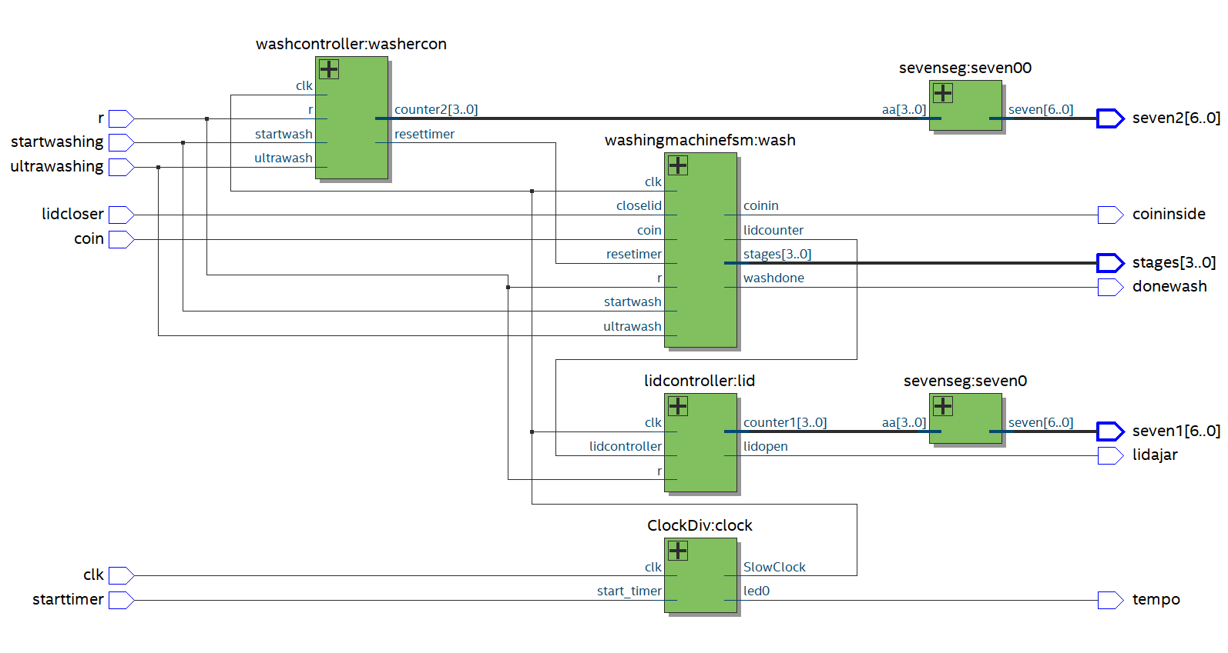

Figure 1.1 Block Diagram of the washing machine design

**Component Description**

Clock divider: The clock divider has a clock signal, a user timer, led and a out signal to distribute a slow, medium or fast signal. The clock signal is tied to the board. The user timer will start the clock divider when called upon. This is connected to a switch for the design. The Led is used to time the clock and see the frequency at which the clock signal is creating an event.

Central Fsm or the washing machine fsm: The finite state machine is the brains of the whole design. The finite state machine is taking in button presses that the user is doing externally on the board. This takes in the buttons to know what washing mode the machine should be on, if a coin is in the device and if the lid has been closed or not. This is the brains of the operation and makes sure it receieves signals to do its job right and effectively.

Seven coder: This is the seven segments of the device. When it gets a 3-bit code from the finite state machine to tell the coder what timer the lid is on and the countdown of the washer to what washing cycle the machine will go next into. This will display all this information on the two seven segment displays. There are two seven segments in my code that handle each function

Lidcontroller: This component keeps track of the lid. If the lid is closed the timer will stop. If the lid is open it will trigger this device and count down until 10 to which it will display an error. The controller is connected to the fsm to make sure those signals reach their point of interest.

Washcontroller: This component controls the washer machine count down. And when it gets a signal to resent the timer it will do that.

**Explanation of block diagram changes**

My block diagram changed with me including another counter. For the most part my design is pretty much the same.

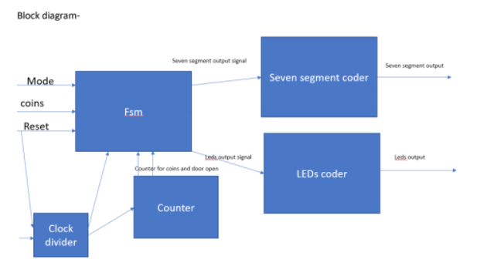

Figure 2- The first block diagram of the washer machine design



Figure 3- A repeat of figure 1

**State Diagram**

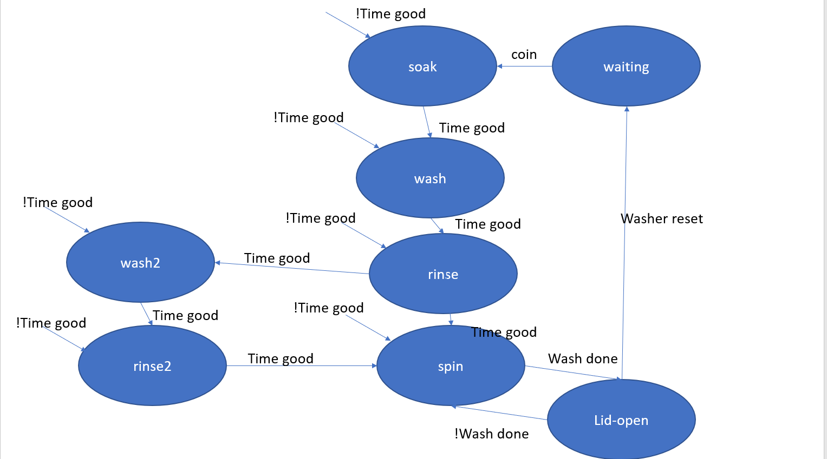

Figure 4- state diagram of the whole washing machine system

The state machine will start at a waiting state. It will then go through the washing states as long is there is no timer reset. If there is timer reset from opening the lid, then should reset that timer. The state machine also accounts for if their ultra-wash becomes a factor in the washing as well.

**Pitfalls and achievements**

During the design of this system, the idea of top down design was a huge achievement. The importance of learning and planning out details before fully implementing them is so important. It is an important component of systems engineering and exactly what is needed in the work world. Learning how to design the system according to the requirements before coding was extremely helpful. There was a little bit of a failure with timing. The lid does what it supposes to, but the washing machine part doesn’t count down and switch states like intended. It is a work in progress.

**VHDL Code**

**Top level**

--top level

library ieee;

use ieee.std_logic_1164.all;

use ieee.std_logic_arith.all;

use ieee.std_logic_unsigned.all;

entity toplevel is

port (clk,r: in std_logic;

coin: in std_logic;

starttimer: in std_logic;

startwashing: in std_logic;

ultrawashing: in std_logic;

lidcloser: in std_logic;

tempo: out std_logic;

coininside: out std_logic;

donewash: out std_logic;

lidajar: out std_logic;

stages: out std_logic_vector(3 downto 0);

seven1: out std_logic_vector(6 downto 0);

seven2: out std_logic_vector(6 downto 0));

end;

architecture beh of toplevel is

signal clockfeeder:std_logic;

signal lidfeeder: std_logic;

signal sevenfeeder: std_logic_vector(3 downto 0);

signal sevenfeeder2: std_logic_vector(3 downto 0);

component clockdiv is

port(clk: in STD_logic;

start_timer: in STD_logic;

FastClock , MediumClock , SlowClock , led0 : out STD_LOGIC );

end component ;

component washingmachinefsm is

port(clk,r: in std_logic;

coin: in std_logic;

startwash: in std_logic;

ultrawash: in std_logic;

closelid: in std_logic;

coinin: out std_logic;

stages: out std_logic_vector(3 downto 0);

washdone: out std_logic;

washcounter: out std_logic_vector( 3 downto 0);

lidcounter: out std_logic);

end component;

component lidcontroller is

port(clk,r, lidcontroller: in std_logic;

lidopen: out std_logic;

counter1: out std_logic_vector(3 downto 0));

end component;

component sevenseg is

Port ( aa : in STD_LOGIC_VECTOR(3 downto 0);

seven : out STD_LOGIC_VECTOR(6 downto 0));

end component;

begin

clock: clockdiv port map(clk=>clk, start_timer=> starttimer, slowclock=>clockfeeder,led0=>tempo);

wash: washingmachinefsm port map(clk=>clockfeeder, r=>r, coin=>coin,startwash=>startwashing,ultrawash=>ultrawashing,closelid=>lidcloser,coinin=>coininside,stages=>stages,washcounter=>sevenfeeder2,washdone=>donewash,lidcounter=>lidfeeder);

lid : lidcontroller port map(clk=>clockfeeder, r=>r, lidcontroller=>lidfeeder,lidopen=>lidajar, counter1=>sevenfeeder);

seven0: sevenseg port map(aa=>sevenfeeder,seven=>seven1);

seven00: sevenseg port map(aa=>sevenfeeder2,seven=>seven2);

end;

**Door timer**

library IEEE;

use IEEE.STD_LOGIC_1164.ALL;

use IEEE.STD_LOGIC_ARITH.ALL;

use IEEE.STD_LOGIC_UNSIGNED.ALL;

entity Doortimer is

port (clk,timego: in std_logic;--clk from the divider and the signal for the timer to start for the door

counter: inout std_logic_vector(1 downto 0));--counter that is used to determine the counter getting to 3

end;

architecture beh of doortimer is

begin

process(clk,timego)

begin

if (clk' event and clk='1') then

if (timego='1') then

counter<=counter +1;--count to 3

elsif(timego='0') then

counter<="00";

end if;

end if;

end process;

end;

**Central fsm**

--central fsm for the elevator

library ieee;

use ieee.std_logic_1164.all;

use ieee.std_logic_arith.all;

use ieee.std_logic_unsigned.all;

entity washingmachinefsm is

port(clk,r: in std_logic;

coin: in std_logic;

startwash: in std_logic;

ultrawash: in std_logic;

closelid: in std_logic;

coinin: out std_logic;

stages: out std_logic_vector(3 downto 0);

washdone: out std_logic;

washcounter: out std_logic_vector( 3 downto 0);

lidcounter: out std_logic);

end;

architecture beh of washingmachinefsm is

type state is ( done,s0,soak,soak1,soak2,soak3, wash,wash1,wash2,wash3, rinse,rinse1,rinse2,rinse3, spin,spin1,spin2,spin3,soaker,soaker1,soaker2,soaker3, rinser,rinser1,rinser2,rinser3);

signal cs, ns: state;

signal stagestmp: std_logic_vector(3 downto 0);

signal washcountertmp: std_logic_vector( 3 downto 0);

begin

process(clk,r)

begin

if( r='1') then

cs<=s0;

elsif(clk'event and clk='1') then

cs<=ns;

end if;

end process;

process(coin,cs,startwash, ultrawash,closelid)

begin

stagestmp<="0000";

washcountertmp<="0000";

coinin<='0';

lidcounter<='0';

washdone<='0';

case cs is

when done=>

if(coin='1') then

ns<=s0;

elsif (coin='0') then

ns<=cs;

end if;

stagestmp<="0000";

washcountertmp<="0000";

when s0=>

if (closelid='0') then

lidcounter<='0';

else

lidcounter<='1';

end if;

if ( startwash='1' and closelid='1' ) then

ns<=soak;

coinin<='1';

elsif( ultrawash='1' and closelid='1' ) then

ns<=soak;

coinin<='1';

end if;

stagestmp<="0000";

washcountertmp<="0000";

when soak=>

if (closelid='0') then

lidcounter<='1';

else

lidcounter<='0';

end if;

if( startwash='1' and closelid='1' ) then

ns<=soak1;

coinin<='1';

elsif( ultrawash='1' and closelid='1') then

ns<=soak1;

coinin<='1';

end if;

stagestmp<="0001";

washcountertmp<="0100";

when soak1=>

if (closelid='0') then

lidcounter<='1';

else

lidcounter<='0';

end if;

if( startwash='1' and closelid='1' ) then

ns<=soak2;

coinin<='1';

elsif( ultrawash='1' and closelid='1') then

ns<=soak2;

coinin<='1';

end if;

stagestmp<="0001";

washcountertmp<="0011";

when soak2=>

if (closelid='0') then

lidcounter<='1';

else

lidcounter<='0';

end if;

if( startwash='1' and closelid='1' ) then

ns<=soak3;

coinin<='1';

elsif( ultrawash='1' and closelid='1') then

ns<=soak3;

coinin<='1';

end if;

stagestmp<="0001";

washcountertmp<="0010";

when soak3=>

if (closelid='0') then

lidcounter<='1';

else

lidcounter<='0';

end if;

if( startwash='1' and closelid='1' ) then

ns<=wash;

coinin<='1';

elsif( ultrawash='1' and closelid='1') then

ns<=wash;

coinin<='1';

end if;

stagestmp<="0001";

washcountertmp<="0000";

when wash=>

if (closelid='0') then

lidcounter<='1';

else

lidcounter<='0';

end if;

if( startwash='1' and closelid='1' ) then

ns<=wash1;

coinin<='1';

elsif( ultrawash='1' and closelid='1' ) then

ns<=wash1;

coinin<='1';

end if;

stagestmp<="0010";

washcountertmp<="0100";

when wash1=>

if (closelid='0') then

lidcounter<='1';

else

lidcounter<='0';

end if;

if( startwash='1' and closelid='1' ) then

ns<=wash2;

coinin<='1';

elsif( ultrawash='1' and closelid='1' ) then

ns<=wash2;

coinin<='1';

end if;

stagestmp<="0010";

washcountertmp<="0011";

when wash2=>

if (closelid='0') then

lidcounter<='1';

else

lidcounter<='0';

end if;

if( startwash='1' and closelid='1' ) then

ns<=wash1;

coinin<='1';

elsif( ultrawash='1' and closelid='1') then

ns<=wash1;

coinin<='1';

end if;

stagestmp<="0010";

washcountertmp<="0010";

when wash3=>

if (closelid='0') then

lidcounter<='1';

else

lidcounter<='0';

end if;

if( startwash='1' and closelid='1' ) then

ns<=rinse;

coinin<='1';

elsif( ultrawash='1' and closelid='1' ) then

ns<=wash1;

coinin<='1';

end if;

stagestmp<="0010";

washcountertmp<="0001";

when rinse=>

if (closelid='0') then

lidcounter<='1';

else

lidcounter<='0';

end if;

if(startwash='1' and closelid='1' ) then

ns<=rinse1;

coinin<='1';

elsif(ultrawash='1' and closelid='1' ) then

ns<=rinse1;

coinin<='1';

end if;

stagestmp<="0100";

washcountertmp<="0100";

when rinse1=>

if (closelid='0') then

lidcounter<='1';

else

lidcounter<='0';

end if;

if(startwash='1' and closelid='1' ) then

ns<=rinse2;

coinin<='1';

elsif(ultrawash='1' and closelid='1' ) then

ns<=rinse2;

coinin<='1';

end if;

stagestmp<="0100";

washcountertmp<="0011";

when rinse2=>

if (closelid='0') then

lidcounter<='1';

else

lidcounter<='0';

end if;

if(startwash='1' and closelid='1' ) then

ns<=rinse3;

coinin<='1';

elsif(ultrawash='1' and closelid='1' ) then

ns<=rinse3;

coinin<='1';

end if;

stagestmp<="0100";

washcountertmp<="0010";

when rinse3=>

if (closelid='0') then

lidcounter<='1';

else

lidcounter<='0';

end if;

if(startwash='1' and closelid='1' ) then

ns<=spin;

coinin<='1';

elsif(ultrawash='1' and closelid='1' ) then

ns<=spin;

coinin<='1';

end if;

stagestmp<="0100";

washcountertmp<="0001";

when spin=>

if (closelid='0') then

lidcounter<='1';

else

lidcounter<='0';

end if;

if( startwash='1' and closelid='1' ) then

ns<=spin1;

washdone<='1';

coinin<='0';

elsif( ultrawash='1' and closelid='1' ) then

ns<=spin1;

coinin<='1';

end if;

stagestmp<="1000";

washcountertmp<="0100";

when spin1=>

if (closelid='0') then

lidcounter<='1';

else

lidcounter<='0';

end if;

if( startwash='1' and closelid='1' ) then

ns<=spin2;

washdone<='1';

coinin<='0';

elsif( ultrawash='1' and closelid='1' ) then

ns<=spin2;

coinin<='1';

end if;

stagestmp<="1000";

washcountertmp<="0011";

when spin2=>

if (closelid='0') then

lidcounter<='1';

else

lidcounter<='0';

end if;

if( startwash='1' and closelid='1' ) then

ns<=spin3;

washdone<='1';

coinin<='0';

elsif( ultrawash='1' and closelid='1' ) then

ns<=spin3;

coinin<='1';

end if;

stagestmp<="1000";

washcountertmp<="0010";

when spin3=>

if (closelid='0') then

lidcounter<='1';

else

lidcounter<='0';

end if;

if( startwash='1' and closelid='1' ) then

ns<=done;

washdone<='1';

coinin<='0';

elsif( ultrawash='1' and closelid='1' ) then

ns<=soaker;

coinin<='1';

end if;

stagestmp<="1000";

washcountertmp<="0001";

when soaker=>

if (closelid='0') then

lidcounter<='1';

else

lidcounter<='0';

end if;

if( ultrawash='1' and closelid='1') then

ns<=soaker1;

coinin<='1';

end if;

stagestmp<="0001";

washcountertmp<="0100";

when soaker1=>

if (closelid='0') then

lidcounter<='1';

else

lidcounter<='0';

end if;

if( ultrawash='1' and closelid='1' ) then

ns<=soaker2;

coinin<='1';

end if;

stagestmp<="0001";

washcountertmp<="0011";

when soaker2=>

if (closelid='0') then

lidcounter<='1';

else

lidcounter<='0';

end if;

if( ultrawash='1' and closelid='1' ) then

ns<=soaker3;

coinin<='1';

end if;

stagestmp<="0001";

washcountertmp<="0010";

when soaker3=>

if (closelid='0') then

lidcounter<='1';

else

lidcounter<='0';

end if;

if( ultrawash='1' and closelid='1' ) then

ns<=rinser;

coinin<='1';

end if;

stagestmp<="0001";

washcountertmp<="0001";

when rinser=>

if (closelid='0') then

lidcounter<='1';

else

lidcounter<='0';

end if;

if(ultrawash='1' and closelid='1' ) then

ns<=rinser1;

washdone<='1';

coinin<='0';

end if;

stagestmp<="0100";

washcountertmp<="0100";

when rinser1=>

if (closelid='0') then

lidcounter<='1';

else

lidcounter<='0';

end if;

if(ultrawash='1' and closelid='1' ) then

ns<=rinser2;

washdone<='1';

coinin<='0';

end if;

stagestmp<="0100";

washcountertmp<="0011";

when rinser2=>

if (closelid='0') then

lidcounter<='1';

else

lidcounter<='0';

end if;

if(ultrawash='1' and closelid='1' ) then

ns<=rinser3;

washdone<='1';

coinin<='0';

end if;

stagestmp<="0100";

washcountertmp<="0010";

when rinser3=>

if (closelid='0') then

lidcounter<='1';

else

lidcounter<='0';

end if;

if(ultrawash='1' and closelid='1' ) then

ns<=done;

washdone<='1';

coinin<='0';

end if;

stagestmp<="0100";

washcountertmp<="0001";

when others=>

null;

end case;

end process;

washcounter<=washcountertmp;

stages<=stagestmp;

end;

**Lidcontroller**

library ieee;

use ieee.std_logic_1164.all;

use ieee.std_logic_arith.all;

use ieee.std_logic_unsigned.all;

entity lidcontroller is

port (clk,r, lidcontroller: in std_logic;

lidopen: out std_logic;--These are all signals that the fsm will send and start the counters

counter1: out std_logic_vector(3 downto 0));--this counter will go back to fsm

end;

architecture beh of lidcontroller is

type state is (s0,s1,s2,s3,s4,s5,s6,s7,s8,s9,s10);

signal cs,ns:state;

signal lidopentmp:std_logic;

begin

process(clk,r)

begin

if(r='1') then

cs<=s0;

elsif (clk' event and clk='1') then

cs<=ns;

end if;

end process;

process(cs,lidcontroller)

begin

case cs is

when s0=>

if (lidcontroller='0') then

counter1<="0000";

lidopentmp<='1';

ns<=s1;

else

ns<=s0;

counter1<="0000";

end if;

when s1=>

if (lidcontroller='0') then

counter1<="0001";

lidopentmp<='1';

ns<=s2;

else

ns<=s0;

counter1<="0000";

end if;

when s2=>

if (lidcontroller='0') then

counter1<="0010";

lidopentmp<='1';

ns<=s3;

else

ns<=s0;

counter1<="0000";

end if;

when s3=>

if (lidcontroller='0') then

counter1<="0011";

lidopentmp<='1';

ns<=s4;

else

ns<=s0;

counter1<="0000";

end if;

when s4=>

if (lidcontroller='0') then

counter1<="0100";

lidopentmp<='1';

ns<=s5;

else

ns<=s0;

counter1<="0000";

end if;

when s5=>

if (lidcontroller='0') then

counter1<="0101";

lidopentmp<='1';

ns<=s6;

else

ns<=s0;

counter1<="0000";

end if;

when s6=>

if (lidcontroller='0') then

counter1<="0110";

lidopentmp<='1';

ns<=s7;

else

ns<=s0;

counter1<="0000";

end if;

when s7=>

if (lidcontroller='0') then

counter1<="0111";

lidopentmp<='1';

ns<=s8;

else

ns<=s0;

counter1<="0000";

end if;

when s8=>

if (lidcontroller='0') then

counter1<="1000";

lidopentmp<='1';

ns<=s9;

else

ns<=s0;

counter1<="0000";

end if;

when s9=>

if (lidcontroller='0') then

counter1<="1001";

lidopentmp<='1';

ns<=s10;

else

ns<=s0;

counter1<="0000";

end if;

when s10=>

if (lidcontroller='0') then

counter1<="1111";

lidopentmp<='1';

ns<=s10;

else

ns<=s0;

counter1<="0000";

end if;

when others=>

counter1<="1111";

end case;

end process;

lidopen<=lidopentmp;

end;

**Wash controller**

library ieee;

use ieee.std_logic_1164.all;

use ieee.std_logic_arith.all;

use ieee.std_logic_unsigned.all;

entity washcontroller is

port(clk,r: in std_logic;

startwash: in std_logic;

ultrawash: in std_logic;

resettimer: out std_logic;

counter2: out std_logic_vector(3 downto 0));

end;

architecture beh of washcontroller is

type state is (s0,s1,s2,s3,s4);

signal cs,ns:state;

begin

process(clk,r)

begin

if(r='1') then

cs<=s0;

elsif (clk'event and clk='1') then

cs<=ns;

end if;

end process;

process(cs,startwash,ultrawash)

begin

case cs is

when s0=>

if (startwash='1') then

counter2<="0100";

ns<=s1;

elsif (ultrawash='1') then

counter2<="0100";

ns<=s1;

else

ns<=s0;

counter2<="0000";

end if;

when s1=>

if (startwash='1') then

counter2<="0011";

ns<=s2;

elsif (ultrawash='1') then

counter2<="0011";

ns<=s2;

else

ns<=s0;

counter2<="0000";

end if;

when s2=>

if (startwash='1') then

counter2<="0010";

ns<=s3;

elsif (ultrawash='1') then

counter2<="0010";

ns<=s3;

else

ns<=s0;

counter2<="0000";

end if;

when s3=>

if (startwash='1') then

counter2<="0001";

ns<=s4;

elsif (ultrawash='1') then

counter2<="0001";

ns<=s4;

else

ns<=s0;

counter2<="0000";

end if;

when s4=>

if (startwash='1') then

counter2<="0000";

ns<=s0;

resettimer<='1';

elsif (ultrawash='1') then

counter2<="0000";

ns<=s0;

resettimer<='1';

else

ns<=s0;

counter2<="0000";

end if;

when others=>

null;

end case;

end process;

end;

**Clock divider**

library IEEE;

use IEEE.STD_LOGIC_1164.ALL;

use IEEE.NUMERIC_STD.ALL;

entity ClockDiv is

port(clk: in STD_logic;

start_timer: in STD_logic;

FastClock , MediumClock , SlowClock , led0 : out STD_LOGIC );

end Clockdiv ;

architecture beh of Clockdiv is

signal slowClock_sig : STD_LOGIC;

begin

process

variable cnt : STD_LOGIC_VECTOR (26 downto 0):= "000000000000000000000000000";

begin

wait until (( clk 'EVENT) AND ( clk = '1'));

if ( start_timer = '0') then

cnt := "000000000000000000000000000" ;

else

cnt := STD_LOGIC_VECTOR( unsigned ( cnt ) + 1);

end if ;

FastClock <= cnt (22);

MediumClock <= cnt (24);

SlowClock <= cnt (26);

slowClock_sig <= cnt (26);

if ( slowClock_sig = '1') then

led0 <= '1';

else

led0 <= '0';

end if ;

end process;

end beh;

**Seven decoder**

library ieee;

use ieee.std_logic_1164.all;

use ieee.std_logic_arith.all;

use ieee.std_logic_unsigned.all;

entity sevenseg is

Port ( aa : in STD_LOGIC_VECTOR(3 downto 0);

seven : out STD_LOGIC_VECTOR(6 downto 0));

end sevenseg;

architecture Behavioral of sevenseg is

begin

process(aa)

begin

Case aa is

when "0000"=> seven <="1000000"; -- '0'

when "0001"=> seven <="1111001"; -- '1'

when "0010"=> seven <="0100100"; -- '2'

when "0011"=> seven <="0110000"; -- '3'

when "0100"=> seven <="0011001"; -- '4'

when "0101"=> seven <="0010010"; -- '5'

when "0110"=> seven <="0000010"; -- '6'

when "0111"=> seven <="1111000"; -- '7'

when "1000"=> seven <="0000000"; -- '8'

when "1001"=> seven <="0011000"; -- '9'

when "1111"=>seven<="1111001"; -- 'E'

when others=> seven <= "1111001";-- everything else would be 0

end case;

end process;

end Behavioral;

**UCF**

# -------------------------------------------------------------------------- #

#

# Copyright (C) 2020 Intel Corporation. All rights reserved.

# Your use of Intel Corporation's design tools, logic functions

# and other software and tools, and any partner logic

# functions, and any output files from any of the foregoing

# (including device programming or simulation files), and any

# associated documentation or information are expressly subject

# to the terms and conditions of the Intel Program License

# Subscription Agreement, the Intel Quartus Prime License Agreement,

# the Intel FPGA IP License Agreement, or other applicable license

# agreement, including, without limitation, that your use is for

# the sole purpose of programming logic devices manufactured by

# Intel and sold by Intel or its authorized distributors. Please

# refer to the applicable agreement for further details, at

# https://fpgasoftware.intel.com/eula.

#

# -------------------------------------------------------------------------- #

#

# Quartus Prime

# Version 20.1.1 Build 720 11/11/2020 SJ Lite Edition

# Date created = 15:30:35 November 23, 2020

#

# -------------------------------------------------------------------------- #

#

# Notes:

#

# 1) The default values for assignments are stored in the file:

# washing_assignment_defaults.qdf

# If this file doesn't exist, see file:

# assignment_defaults.qdf

#

# 2) Altera recommends that you do not modify this file. This

# file is updated automatically by the Quartus Prime software

# and any changes you make may be lost or overwritten.

#

# -------------------------------------------------------------------------- #

set_global_assignment -name FAMILY "MAX 10"

set_global_assignment -name DEVICE 10M50DAF484C7G

set_global_assignment -name TOP_LEVEL_ENTITY toplevel

set_global_assignment -name ORIGINAL_QUARTUS_VERSION 20.1.1

set_global_assignment -name PROJECT_CREATION_TIME_DATE "15:30:35 NOVEMBER 23, 2020"

set_global_assignment -name LAST_QUARTUS_VERSION "20.1.1 Lite Edition"

set_global_assignment -name VHDL_FILE ../../Downloads/timingcontroller.vhd

set_global_assignment -name VHDL_FILE "../../Downloads/washing-machine.vhd"

set_global_assignment -name VHDL_FILE ../../Downloads/clockdiv.vhd

set_global_assignment -name PROJECT_OUTPUT_DIRECTORY output_files

set_global_assignment -name MIN_CORE_JUNCTION_TEMP 0

set_global_assignment -name MAX_CORE_JUNCTION_TEMP 85

set_global_assignment -name DEVICE_FILTER_PIN_COUNT 484

set_global_assignment -name DEVICE_FILTER_SPEED_GRADE 7

set_global_assignment -name ERROR_CHECK_FREQUENCY_DIVISOR 256

set_global_assignment -name VHDL_FILE washingcontroller.vhd

set_global_assignment -name VHDL_FILE sevensegdecoder.vhd

set_global_assignment -name VHDL_FILE toplevel.vhd

set_global_assignment -name PARTITION_NETLIST_TYPE SOURCE -section_id Top

set_global_assignment -name PARTITION_FITTER_PRESERVATION_LEVEL PLACEMENT_AND_ROUTING -section_id Top

set_global_assignment -name PARTITION_COLOR 16764057 -section_id Top

set_location_assignment PIN_P11 -to clk

set_instance_assignment -name IO_STANDARD "3.3-V LVTTL" -to clk

set_location_assignment PIN_C10 -to coin

set_instance_assignment -name IO_STANDARD "3.3-V LVTTL" -to coin

set_location_assignment PIN_A8 -to coininside

set_instance_assignment -name IO_STANDARD "3.3-V LVTTL" -to coininside

set_location_assignment PIN_A9 -to donewash

set_location_assignment PIN_A10 -to lidajar

set_instance_assignment -name IO_STANDARD "3.3-V LVTTL" -to donewash

set_instance_assignment -name IO_STANDARD "3.3-V LVTTL" -to lidajar

set_location_assignment PIN_C11 -to lidcloser

set_location_assignment PIN_B14 -to r

set_instance_assignment -name IO_STANDARD "3.3-V LVTTL" -to lidcloser

set_instance_assignment -name IO_STANDARD "3.3-V LVTTL" -to r

set_location_assignment PIN_F15 -to starttimer

set_location_assignment PIN_A14 -to startwashing

set_location_assignment PIN_A13 -to ultrawashing

set_location_assignment PIN_B11 -to tempo

set_instance_assignment -name IO_STANDARD "3.3-V LVTTL" -to ultrawashing

set_instance_assignment -name IO_STANDARD "3.3-V LVTTL" -to tempo

set_instance_assignment -name IO_STANDARD "3.3-V LVTTL" -to startwashing

set_instance_assignment -name IO_STANDARD "3.3-V LVTTL" -to starttimer

set_location_assignment PIN_C14 -to seven1[0]

set_location_assignment PIN_E15 -to seven1[1]

set_location_assignment PIN_C15 -to seven1[2]

set_location_assignment PIN_C16 -to seven1[3]

set_location_assignment PIN_E16 -to seven1[4]

set_location_assignment PIN_D17 -to seven1[5]

set_location_assignment PIN_C17 -to seven1[6]

set_instance_assignment -name IO_STANDARD "3.3-V LVTTL" -to seven1[6]

set_instance_assignment -name IO_STANDARD "3.3-V LVTTL" -to seven1[5]

set_instance_assignment -name IO_STANDARD "3.3-V LVTTL" -to seven1[4]

set_instance_assignment -name IO_STANDARD "3.3-V LVTTL" -to seven1[3]

set_instance_assignment -name IO_STANDARD "3.3-V LVTTL" -to seven1[2]

set_instance_assignment -name IO_STANDARD "3.3-V LVTTL" -to seven1[1]

set_instance_assignment -name IO_STANDARD "3.3-V LVTTL" -to seven1[0]

set_instance_assignment -name IO_STANDARD "3.3-V LVTTL" -to seven1

set_location_assignment PIN_C18 -to seven2[0]

set_location_assignment PIN_D18 -to seven2[1]

set_location_assignment PIN_E18 -to seven2[2]

set_location_assignment PIN_B16 -to seven2[3]

set_location_assignment PIN_A17 -to seven2[4]

set_location_assignment PIN_A18 -to seven2[5]

set_location_assignment PIN_B17 -to seven2[6]

set_instance_assignment -name IO_STANDARD "3.3-V LVTTL" -to seven2[6]

set_instance_assignment -name IO_STANDARD "3.3-V LVTTL" -to seven2[5]

set_instance_assignment -name IO_STANDARD "3.3-V LVTTL" -to seven2[4]

set_instance_assignment -name IO_STANDARD "3.3-V LVTTL" -to seven2[3]

set_instance_assignment -name IO_STANDARD "3.3-V LVTTL" -to seven2[2]

set_instance_assignment -name IO_STANDARD "3.3-V LVTTL" -to seven2[1]

set_instance_assignment -name IO_STANDARD "3.3-V LVTTL" -to seven2[0]

set_instance_assignment -name IO_STANDARD "3.3-V LVTTL" -to seven2

set_location_assignment PIN_A11 -to stages[0]

set_location_assignment PIN_D14 -to stages[1]

set_location_assignment PIN_E14 -to stages[2]

set_location_assignment PIN_C13 -to stages[3]

set_instance_assignment -name IO_STANDARD "3.3-V LVTTL" -to stages[0]

set_instance_assignment -name IO_STANDARD "3.3-V LVTTL" -to stages[1]

set_instance_assignment -name IO_STANDARD "3.3-V LVTTL" -to stages[2]

set_instance_assignment -name IO_STANDARD "3.3-V LVTTL" -to stages[3]

set_instance_assignment -name IO_STANDARD "3.3-V LVTTL" -to stages

set_location_assignment PIN_B12 -to washeron

set_instance_assignment -name PARTITION_HIERARCHY root_partition -to | -section_id Top

**References**

1. The Deo Lab manual within blackboard
2. Class notes from ECEN 424 on fsm, timers, and top down design

**Conclusion**

The project involving the washing machine was a failure this time around. A lot of it came from trying to do more than I needed to and not just getting down the basics. The pitfalls and achieved helped implement growth as a student and a FPGA programmer. The elevator helps to teach the important of top down design, finite state machines, and timers in VHDL.